Supplementary material for

Circulating exosome-derived miR-191-5p promote tumor progression and enhances radioresistance by targeting DAPK1 in esophageal squamous cell carcinoma
Huan Wang¹², Masayuki Kano¹, Yasunori Matsumoto¹, Takeshi Toyozumi¹, Satoshi Endo¹, Hiroshi Suito¹, Toshiki Kamata¹, Koichiro Okada¹, Tadashi Shiraishi¹, Hongxu Liu², Takahiro Ryuzaki¹, Soichiro Hirasawa¹, Masaya Yokoyama¹, Kazuya Kinoshita¹, Keiko Iida¹, Kentaro Murakami¹, Haruhito Sakata¹, and Hisahiro Matsubara¹

1. Department of Frontier Surgery, Chiba University, Chiba, Japan.
2. Department of Thoracic Surgery, Cancer Hospital of China Medical University, Liaoning Cancer Hospital & Institute, Shenyang, China.

Supplementary methods
Patients
We retrospectively investigated the patients who received radiotherapy as an initial treatment with or without esophagectomy (with two- or three-field lymph node dissection, if necessary) between 2011 and 2017. The patient medical records and survival status were retrospectively reviewed in August 2018. Patients were deemed eligible for this study if they (1) had been pathologically diagnosed with ESCC, (2) were between 20 and 85 years of age, and (3) did not have any other kinds of cancer. The data of 67 patients were retrospectively examined after excluding the patients who did not meet these criteria.
The TNM system (UICC, 8th edition) was used to classify the ESCC stages in these patients. The TRG-PT was classified into 5 categories according to the ratio of viable cancer cells per tumor tissue, as follows: grade 0, no therapeutic effect; grade 1a, viable cancer cells ≥2/3; grade 1b, 1/3 ≤ viable cancer cells <2/3; grade 2, viable cancer cells <1/3; and grade 3, no viable cancer cells[1]. The patient characteristics (age, sex, and pathological evaluation findings) are shown in Table 2.

1. Kadota T, Hatogai K, Yano T, Fujita T, Kojima T, Daiko H et al: Pathological tumor regression grade of metastatic tumors in lymph node predicts prognosis in esophageal cancer patients. Cancer Sci 2018, 109(6):2046-2055.

Supplementary figure legends
Figure S1. qRT-PCR of miR-191-5p expression in TE11 and KYSE-960 transfected miR-191-5p or negative control. The cell lines TE11 and KYSE-960 were seeded into 6-well plates (2.5×10⁵ cells per well), and after 24 h, cells were transfected with miR-191 mimic or negative control mimic using LipofectamineTM RNAi-MAX.

Figure S2. TE11 (A) and KYSE-960 (B) were transfected with miR-191-5p or negative control. At 48 h after transfection, cells were starved for 24 h and then harvested. The cell cycle distributions of TE11 and KYSE-960 were measured using flow cytometry. **P < 0.01 compared with the negative control.

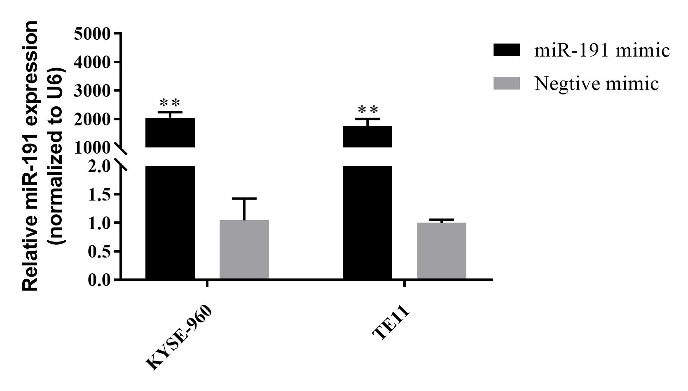

Fig.S1

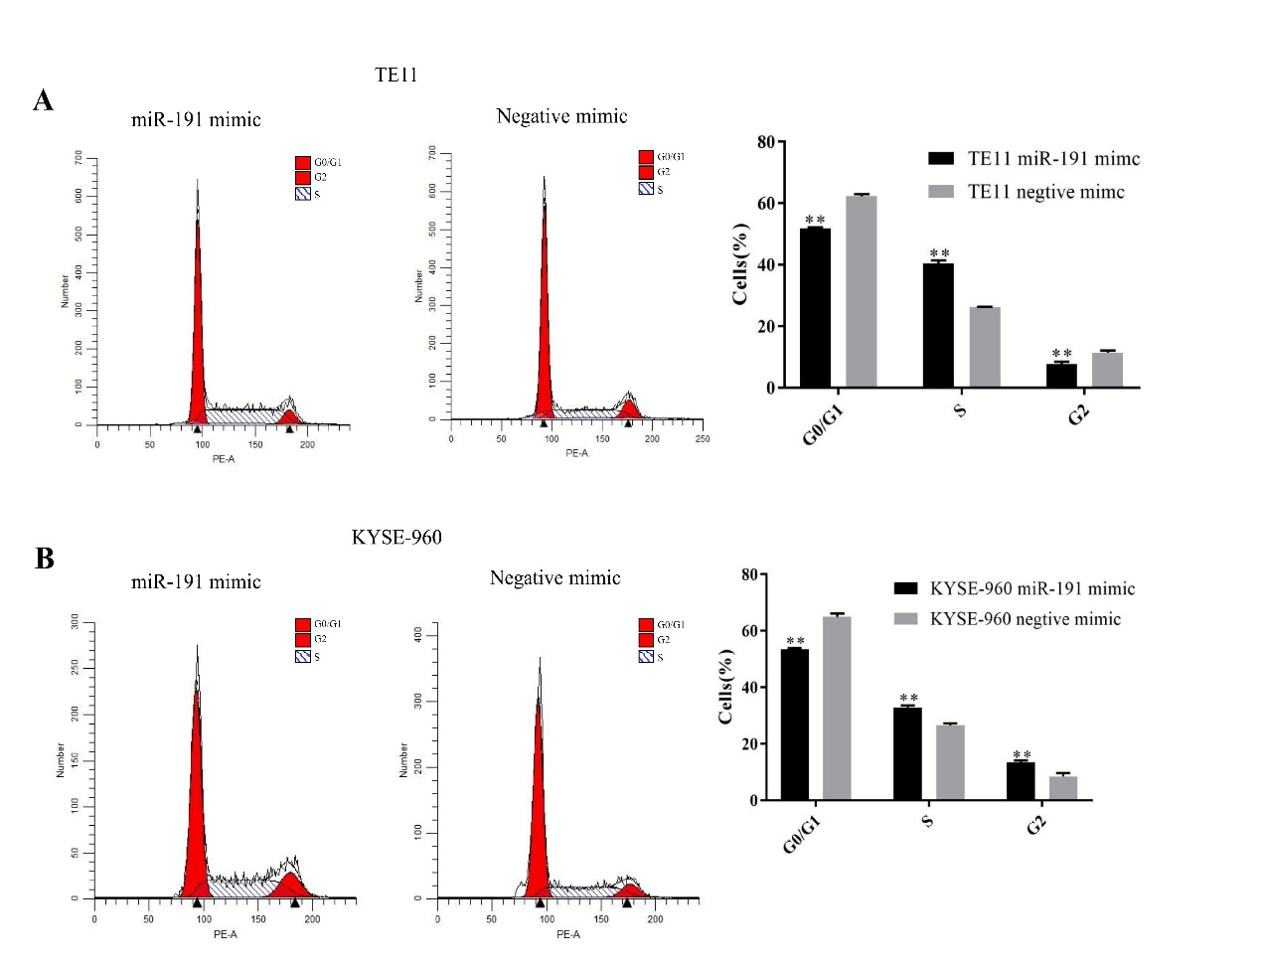

Fig. S2

